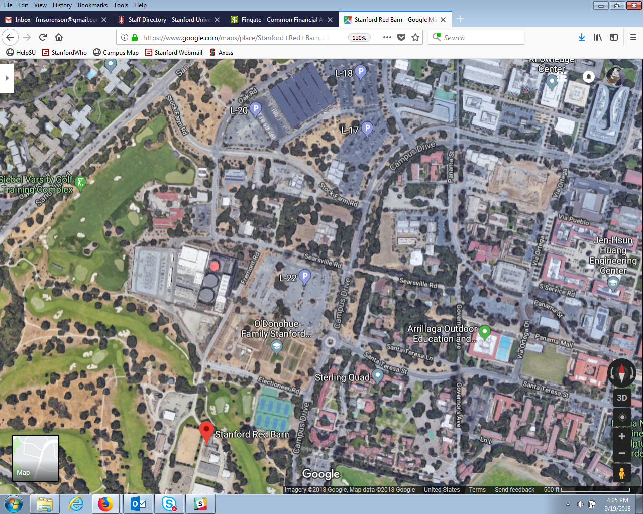

**SPECTATOR PARKING**

**Hole 2 - Course Start/Finish**

**SPECTATOR PARKING**

**SPECTATOR PARKING**

**SPECTATOR PARKING**