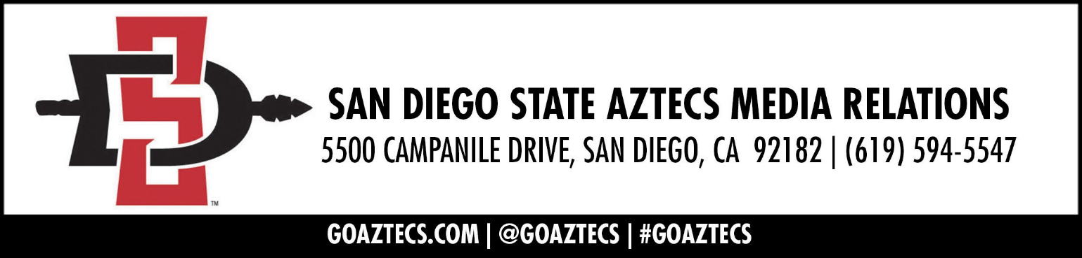

Head Coach Brian Dutcher
Opening Statement:
“We had a closed scrimmage against Arizona State. Now we had a scrimmage in front of fans with the lights on to see what that would feel like and I like my team. We've got a long way to go. It's playing together, it's making each other better. We've got a lot of really good pieces but it takes a while to build a team and we're in that process right now. So we'll take some of the good and the bad from today's performance and get ready for our opener against a very good Fullerton team on the sixth but happy with where we're at. But now we've got a long way to go.”

On what he learned about the team in a live action game with a crowd:
“It's just what you'd expect. I have a lot of really good talented players. They're trying to figure out how they fit within the offense and sometimes they press a little too hard, which I understand that's the nature of the game. So at some point we'll get really comfortable playing together. We're not there yet. We have good pieces but we're not a great team offensively yet, because we have to learn to play better together.”

On what the team looks like defensively:
“We pick up full court, we pressure the ball and we switch some screens and they made some threes. But the hard thing is just maintaining your concentration. That's the hardest thing in basketball. When something doesn't go right or you make a mistake is to concentrate at the other end of the floor. That's just maturity. That's why the older guys do it better than the younger guys because they’ve played more so they've all got to get comfortable in their roles and continue to grow their games within what we do as a team.”

Sophomore Forward Elijah Saunders
On how we will make his offensive presence known this season:
“I would just say knowing when to roll and knowing when to pop. I feel like sometimes today I popped too much and I didn't take advantage of my size inside. Just finding that balance between rolling and popping and when to play powerful and when to step up on the perimeter. That's going to be the biggest challenge with that.”

Senior Forward Jaedon LeDee
On if he takes pride in his ability to take fouls:
“I didn't really think about it like that. I decided to make my presence known and play physical. That’s what we kind of want to carry over from last year to this year to start off the game and set the tone.”

-SDSU-

